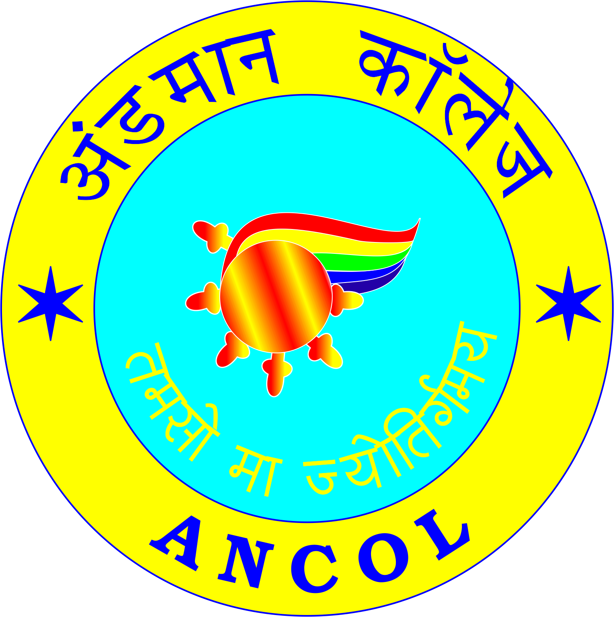अंडमानकॉलेज/ANDAMAN COLLEGE

**अंडमानऔरनिकोबारप्रशासन/ANDAMAN & NICOBAR ADMINISTRATION**

(Affiliated to Pondicherry University)

***श्रीविजयपुरम/*SRI VIJAYA PURAM**

**College No: 1027 E-mail Id: *andamancollege@gmail.com***

F.No:7-1/ANCOL/Admission/2025-26 / Dated: 30/05/2025

**DETAILS OF RESERVATION IN STUDENT’S ADMISSION AT ANCOL IN VARIOUS UG COURSES FOR THE ACADEMIC YEAR 2025-26**

|  |  |  |  |  |  |  |  |  |
| --- | --- | --- | --- | --- | --- | --- | --- | --- |
| Sl.No | Courses Offered | Intake Capacity | GEN | OBC 27% | ST  7.5% | Divyang 5% | ESM 1% | EWS 10% |
| 1 | B.Com ( General) | 66 | 35 | 16 | 5 | 3 | 1 | 6 |
| 2 | B.Com ( Corporate Secrateryship) | 66 | 35 | 16 | 5 | 3 | 1 | 6 |
| 3 | B.A ( English) | 66 | 35 | 16 | 5 | 3 | 1 | 6 |
| 4 | B.A (Economics) | 66 | 35 | 16 | 5 | 3 | 1 | 6 |
| 5 | BBA ( Bachelor of Business Administration) | 33 | 19 | 8 | 2 | 1 | 0 | 3 |
| 6 | B.Sc ( Psychology) | 33 | 19 | 8 | 2 | 1 | 0 | 3 |
| 7 | B.A ( Sociology) | 33 | 19 | 8 | 2 | 1 | 0 | 3 |
| 8 | B.A ( Sociology) | 33 | 19 | 8 | 2 | 1 | 0 | 3 |
| Total Intake Capacity | | 396 | 216 | 96 | 28 | 16 | 4 | 36 |

Dr.S.Jayakumar

Principal

Andaman College ( ANCOL)

Sri Vijaya Puram.