Instructions to Common Service Centres, A & N Islands
  - Candidates are advised to see the newspaper advertisement and follow the news broadcast of All India Radio.
  - Candidates can access the e-Brochure over Internet with the URL http://collegeadmission.andaman.gov.in
  - Candidates have two options; either they fill the Admission Application Form through Common Service Center (CSC) or through internet by accessing the portal via URL http://collegeadmission.andaman.gov.in.
- CSC operators are advised to enter the requisite information correctly as per the format available in the common admission portal published in ANSDC.
- Scan all the relevant documents in .jpg format and upload the same in the common application portal.
- CSC operators are advised to give the payment receipt to the candidates after successful completion of application forms along with system generated acknowledgment slip with seal.
- If the candidates are applying through CSC, they are advised to pay the charges/fees at CSC Counter for filling up the application forms based on the criteria as stated below:
    - Filling in Application Form at Rs 10/-
    - Scanning & Uploading documents/testimonials including photograph in Color format at Rs. 10/- per document and Black & White Format at Rs. 5/- per document
    - Print out of Acknowledgement Slip: @5/-
- The candidates MUST bring the acknowledgment slip (with the seal of CSC if applied through CSC), Original Documents with self attested photocopy of documents during the counselling session of their opted college(s).
- In case candidates fails to produce their acknowledgment slip during counselling for Admission in respective colleges, their candidature will be treated as cancelled.
- During the claims and objection, the students can point out the discrepancy in marks and category for any candidate including his/her own application supported by documentary evidence. No claims for change of preference in terms of colleges/courses shall be entertained.
INSTRUCTIONS WITH SCREENSHOT FOR FILLING COMMON ONLINE ADMISSION FORM
- Home Page of Common College Admission Portal (College Prospectus/e-Brochure Section)
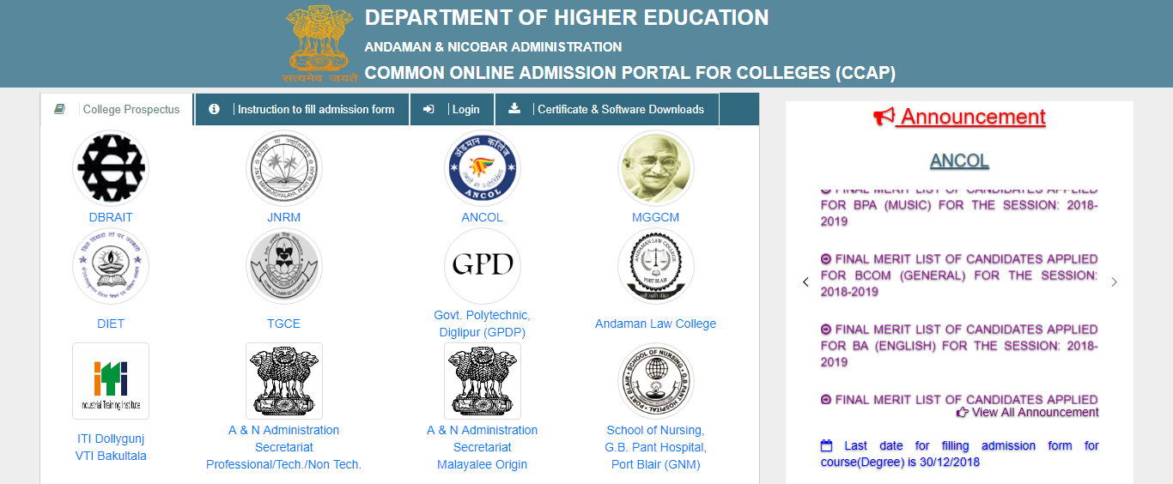
e-Brochure of all the Institute
Announcement Institute Wise
Click to view more
Important Dates

- Home Page of Common College Admission Portal (Instruction how to fill Admission Form Section)
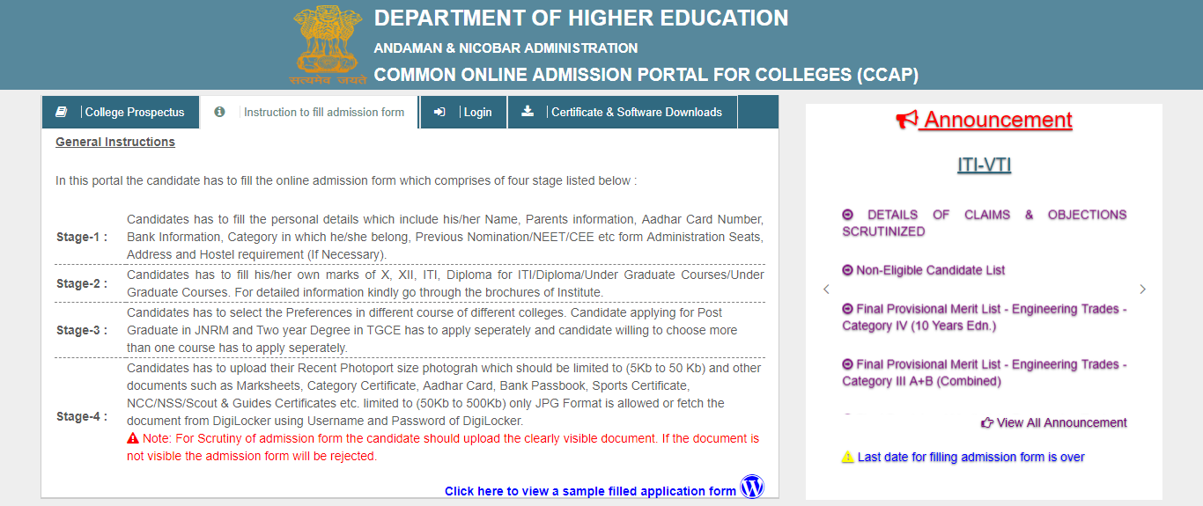
Instruction to fill Admission Form
Click to view SOP on how to fill Admission Form

- Home Page of Common College Admission Portal (CSC Zone in Login Section)
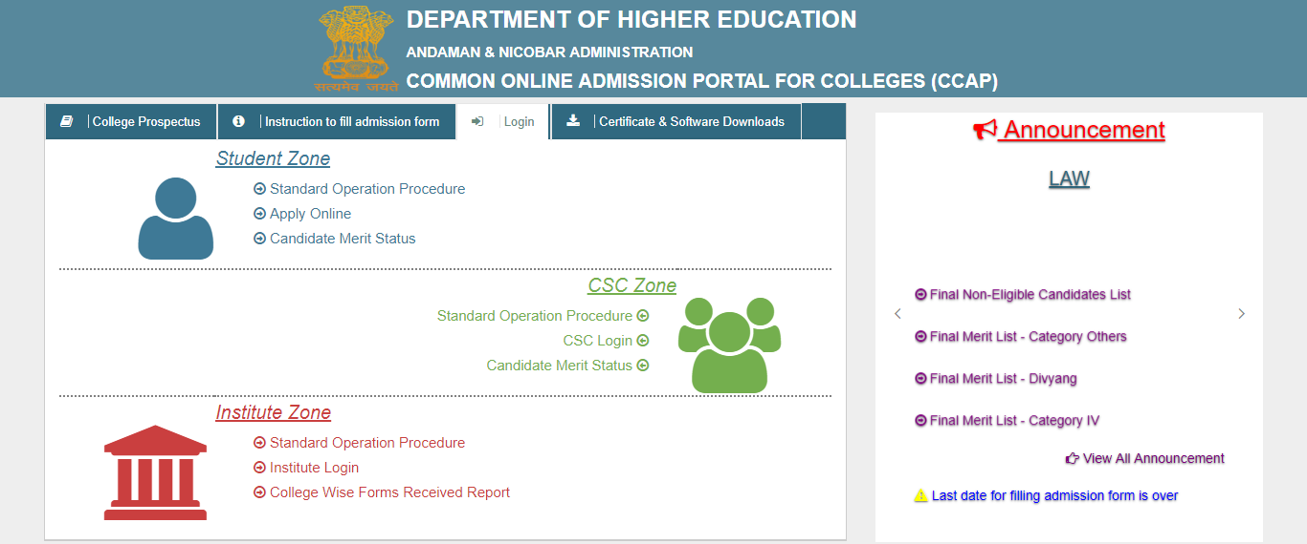
Click to view SOP on how to fill Admission Form
Click to Apply Online
Click to view Institute wise merit Status

- Home Page of Common College Admission Portal (Certificate & Software Download Section)
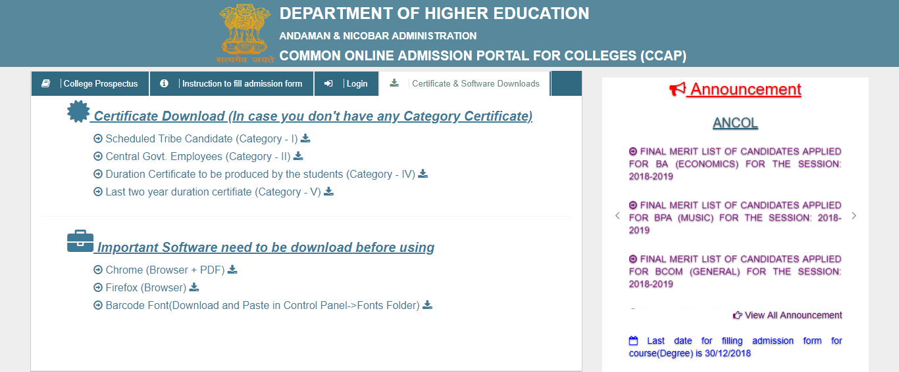
If you don’t have any Category Certificate Download
For better view of CCAP portal download and install the browser
For Barcode download and paste in Control Panel->Fonts (Folder)
- Candidate Login Form
Registered Candidate can login in with Registration no and Registration Key and Click on Login
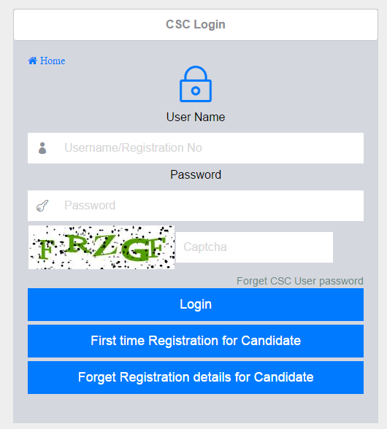
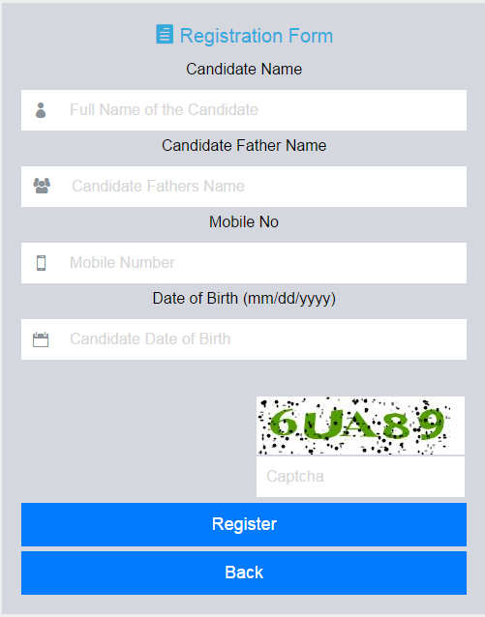
For new candidate click on “First time Registration for Candidate”

Registered User Name and Five Character of you location - Required for Recover the Login Details

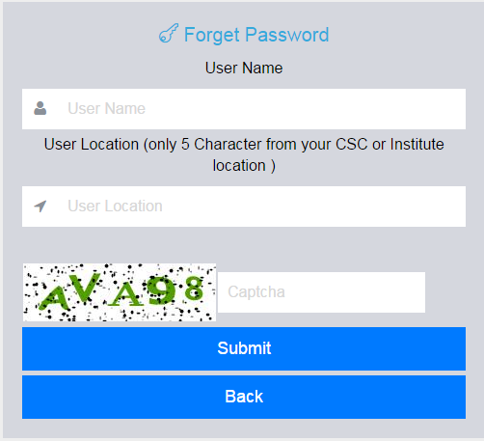
If Candidate forget Registration No or Password click on “Forget Registration details for Candidate”

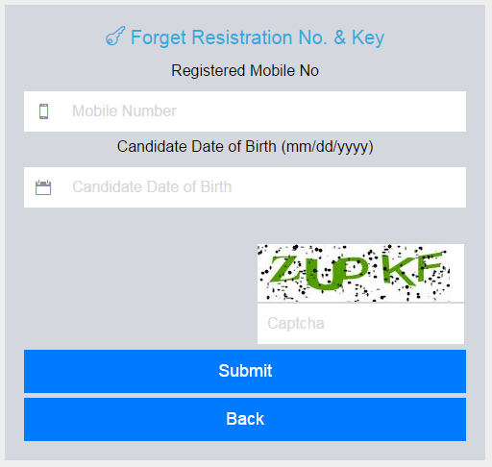
Candidate Name, Father Name, Mobile No, Date of Birth - Required for Registration No and Registration Key
Registered Mobile No and Date of Birth - Required for Recover the Registration no and Registration Key

- Please provide the Candidate Registration No. and Registration Key for filling of Application Login

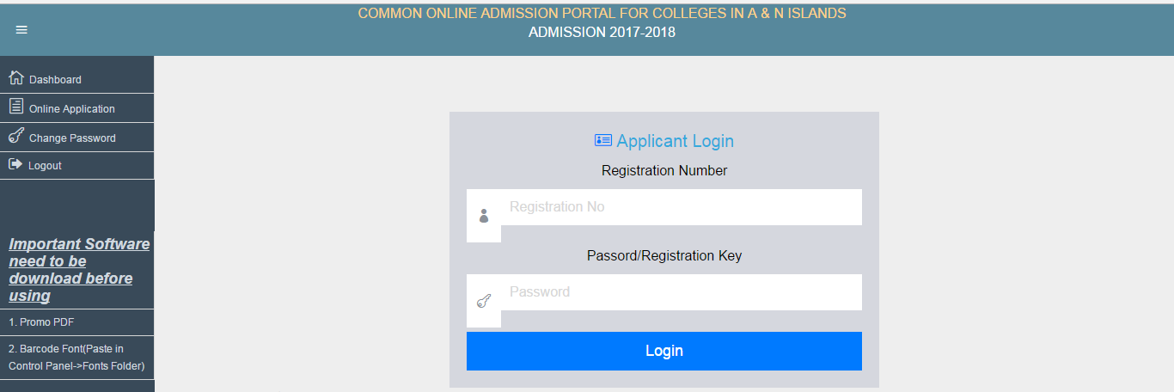
7. Filling of the online Admission Form is comprises of 4 level.
  - Level 1: Candidates will fill the personal details which include his/her name, address, category and hostel requirement (If Necessary).
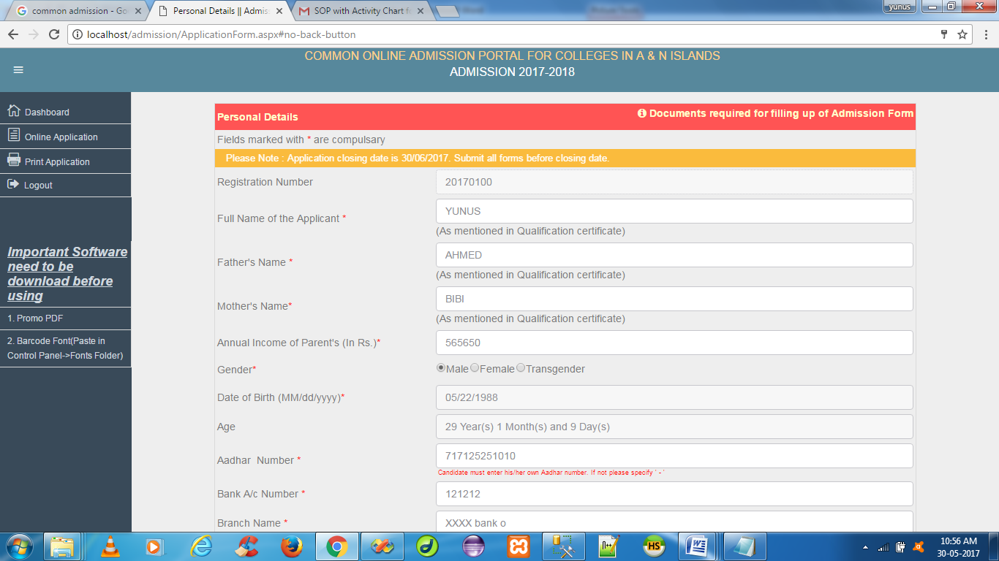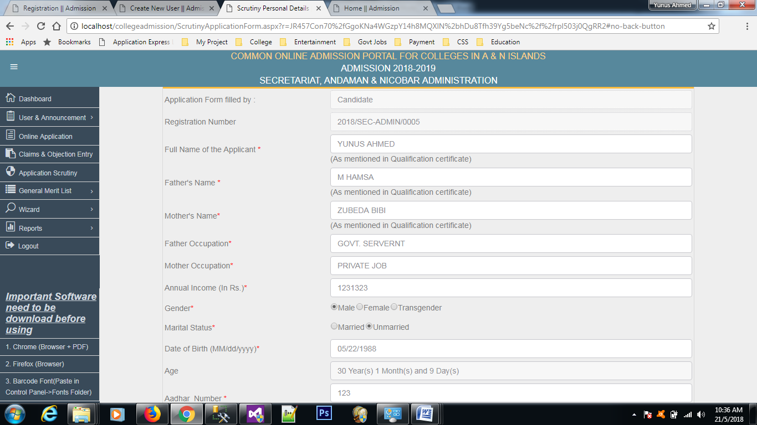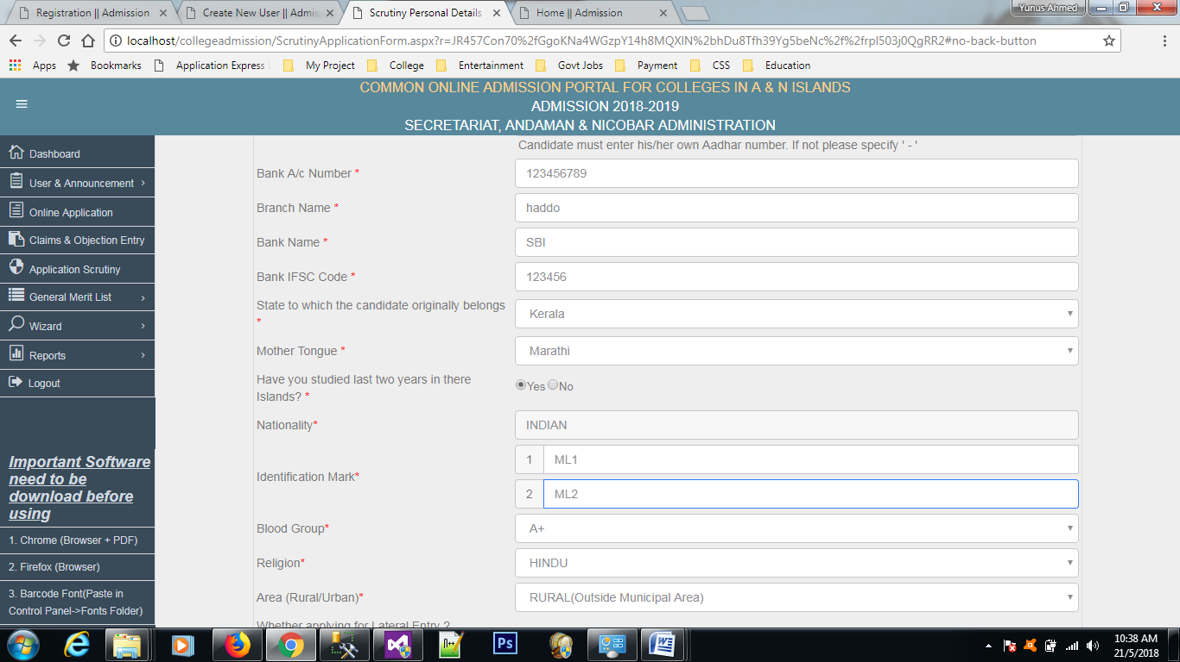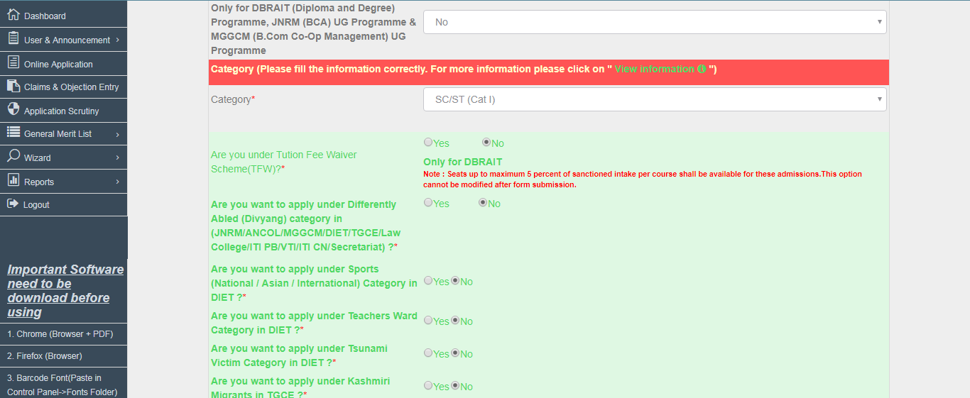
“Documents required for filling up of Admission Form”
For category information click on “View Information”
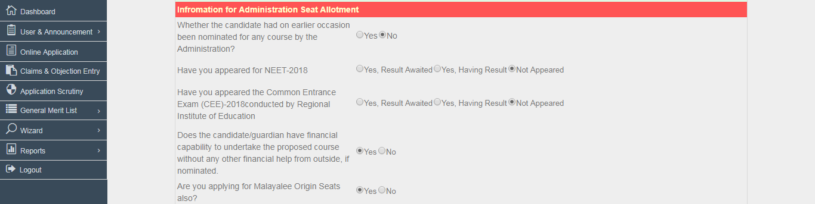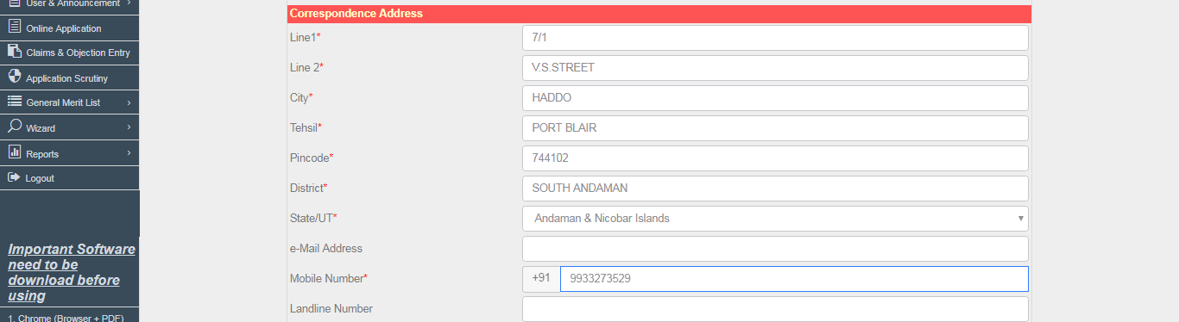
Candidate applying for A & N Administration Mainland Seat Allotment
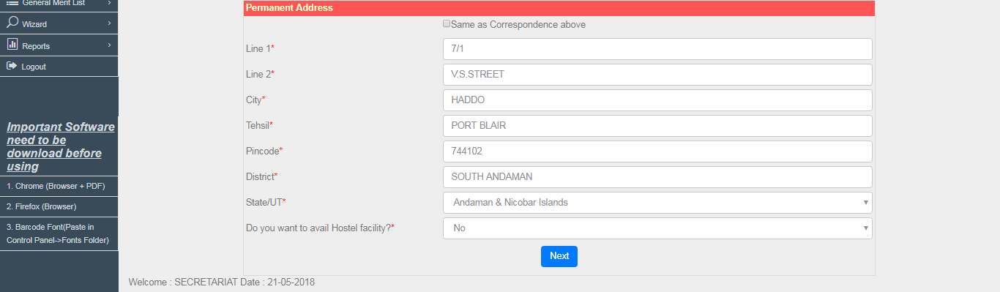

  - Level 2: Candidates will fill his/her own marks of X, XII, ITI, Diploma, Under Graduate, Post Graduate.
    - Entering of Class 10 and 10+2 Marks for all the Subject Marks is mandatory for applying in Under Graduate Programs in all the Institute(s) and Hotel Management Course, Maritime Course in DBRAIT, Administration seat allotment and Stenography & Secretarial Assistant in ITI.
    - Entering of Class 10 and 10+2 Science Marks for all the Subject Marks is mandatory for applying in Diploma Course in DBRAIT and Trade Diploma in ITI/VTI(s).
    - Entering of Class 10 and 10+2 Marks (if poses) for all the Subject Marks is mandatory for applying in Trade Diploma Course in DBRAIT &amp; few courses available in Administration Seats Allotment.
    - Entering of Class 10 for all the subjects along with Diploma total marks is mandatory for applying in Lateral Entry Degree in DBRAIT,JNRM,MGGCM &amp; Entering of Class 10 for all the subjects along with ITI Trade total marks is mandatory for applying in Lateral Entry Diploma in DBRAIT.
    - Entering of Class 10 for all the subjects along with all semester/year subject wise marks is mandatory for applying in Post Graduate course in JNRM, Two Year course in TGCE & B.Ed Bhopal in Administration Seat allotment.

In case, If the candidate want to correct any data ,then click on ‘delete’ and then again fill the marks and click on ‘add’ button.
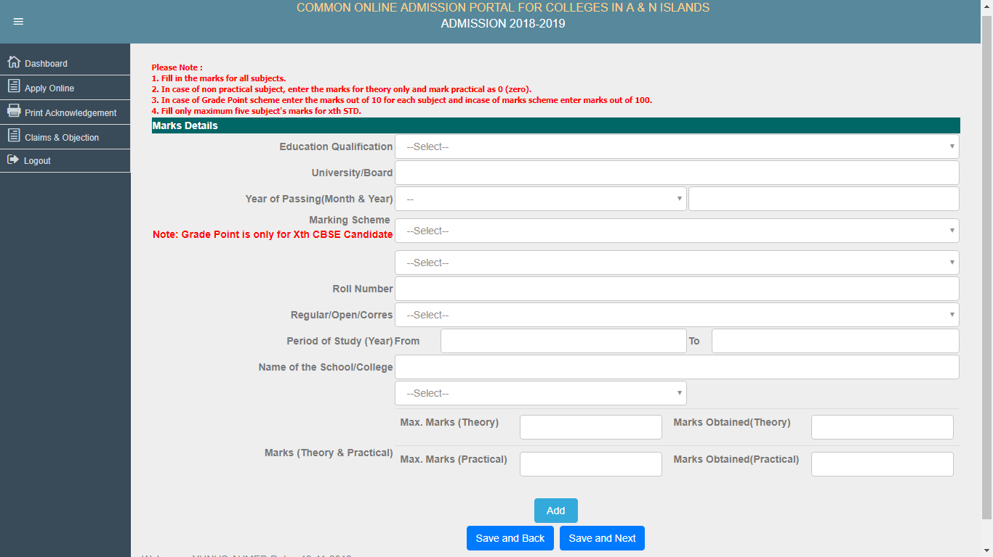
After enter the details click on “ADD”

  - Level 3: Candidates will select the Preferences in different course of different college's
- Select Institute, Programme Name, Course Name, Preference
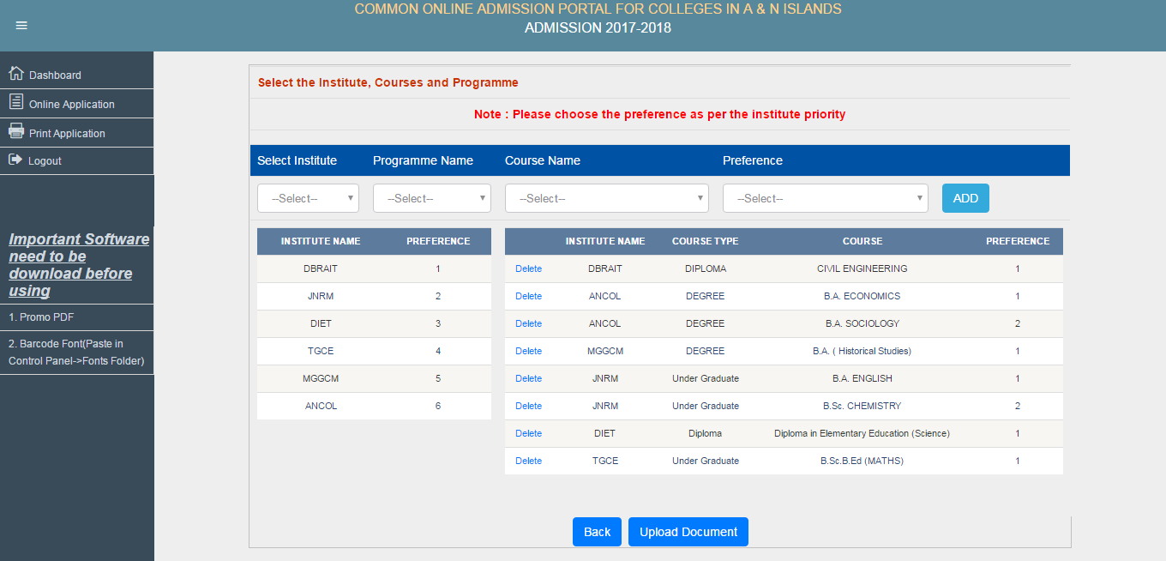
Institute Priority will be shown based on Preference
Institute wise course priority will be shown
After select of college Click on “ADD”

  - Level 4: Candidates will upload their Photographs which should be limited to (5Kb to 50 Kb) and other documents such as Marksheets, Category Certificate, Aadhar Card, Bank Passbook, Sports Certificate, NCC/NSS/Scout & Guides Certificates limited to (50Kb to 500Kb) only JPG Format is allowed.
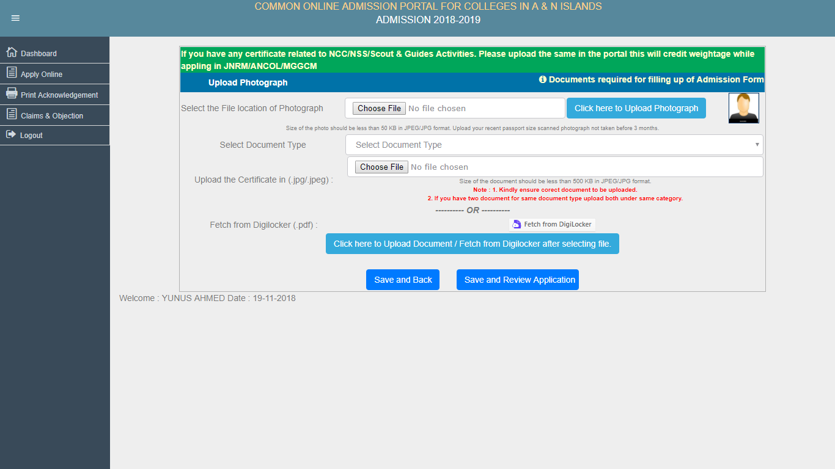
After selecting the document type upload scan document or fetch the document from Digilocker
“Documents required for filling up of Admission Form”

  - After completion of filling up of online application form Level 1 to Level 4 click on “Review Application” in which the candidate will get the basic information regarding of all Level 1 to Level 5 fill details.
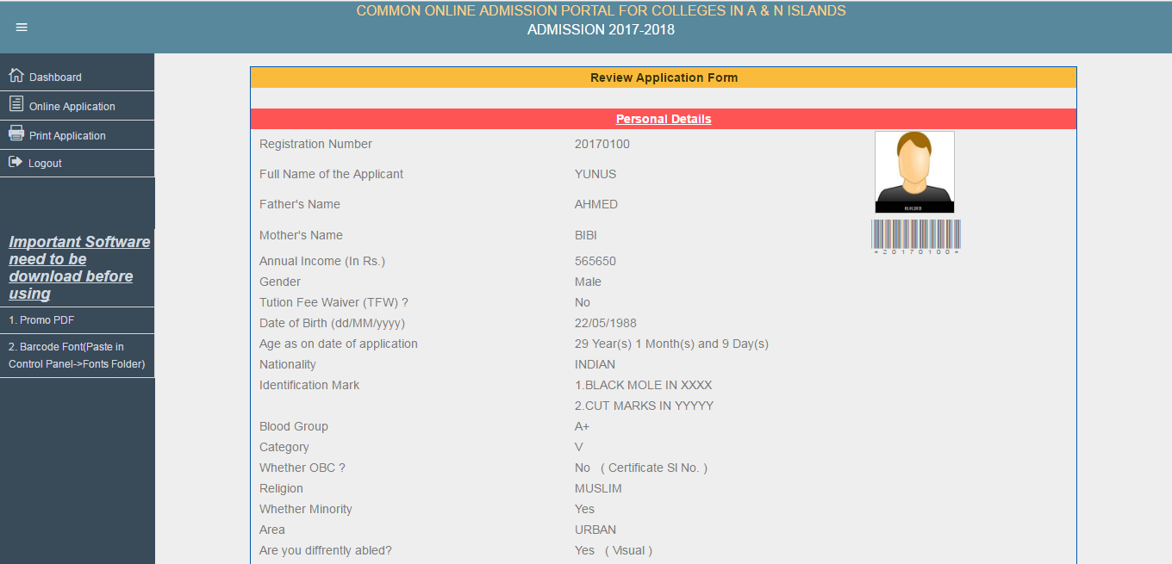
For Barcode Download “Barcode font” and paste in Control Panel -> Fonts Folder
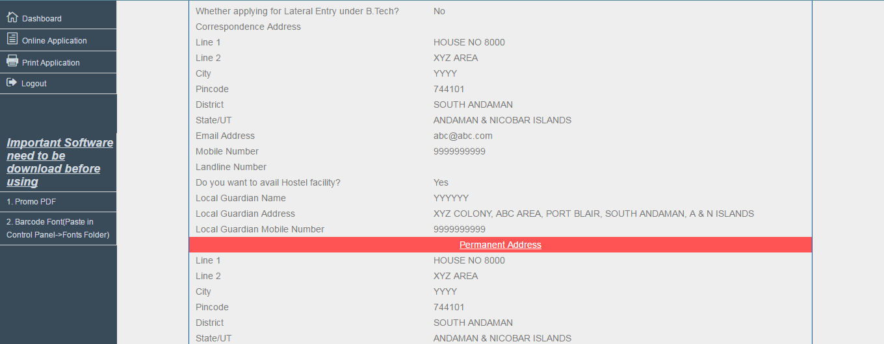
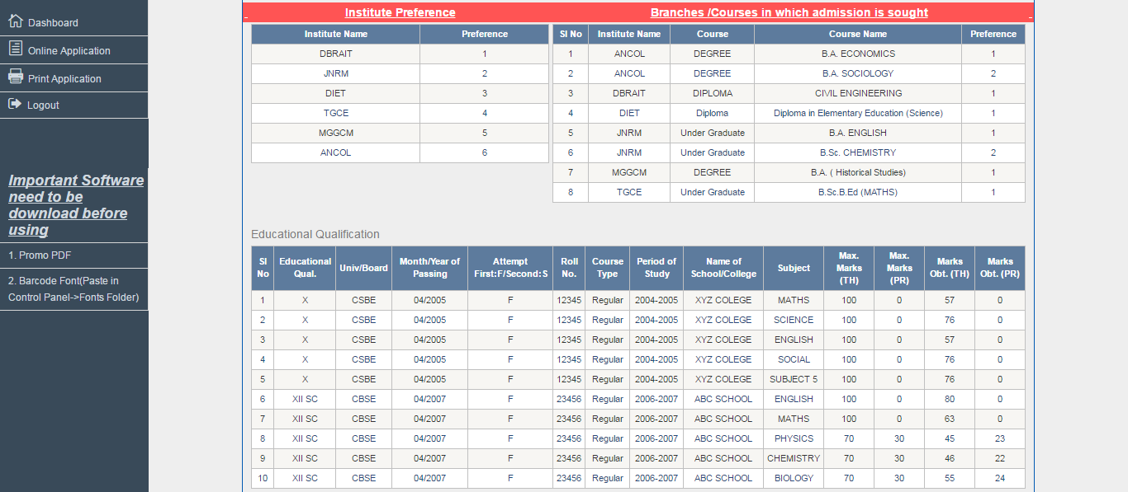

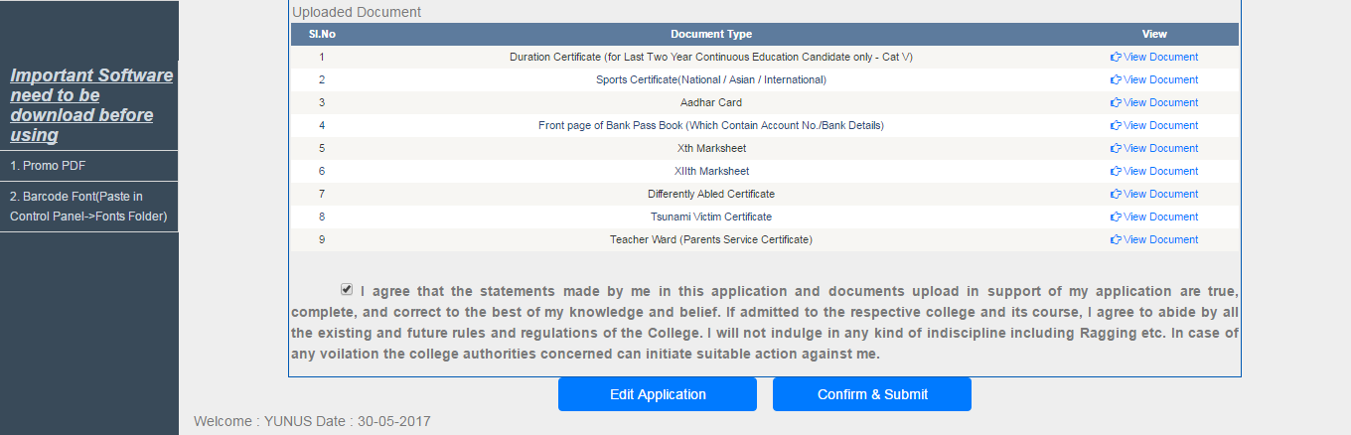
For any alteration click on “Edit Application”
For submitting the online application form click on “Confirm & Submit”. Before submit click on “I agree”

- After submitting the online application form the candidate will received the computer generated “Acknowledgement Slip” in which the all the selected coursed of respective college’s will be display. The candidate should bring the Acknowledgement Slip and original documents/testimonials along with self attested photocopy during counselling session of respective colleges
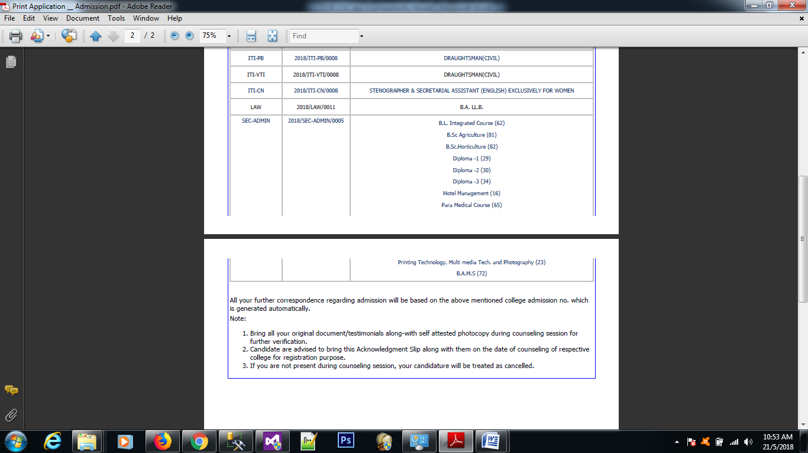
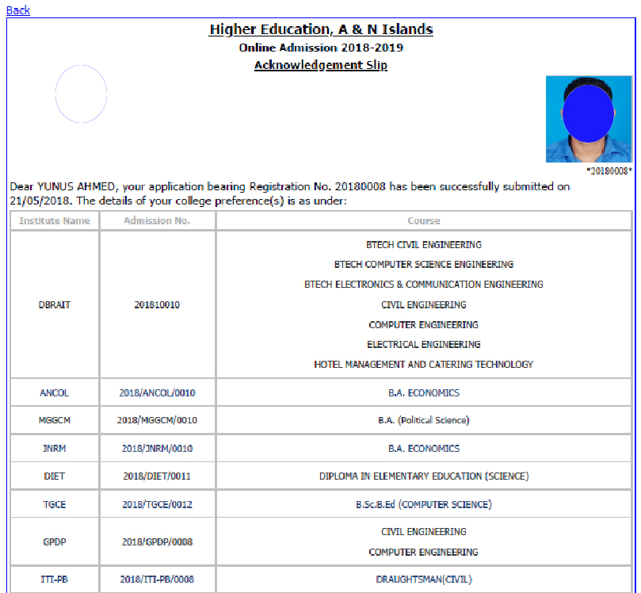

For any claims and objection candidate need to apply online using Registration No. and Registration Key via link available “Claims & Objection” only after display of college wise provisional merit list.

